MIDDLE EAST FUJI L.L.C.

Govind

MOB. NO. +971 52 926 0592

E mail id: govins@mef.ae

1. 3M BRANDS

ABRASHIVE ( DISC, HOOKIT, SANDPAPER, EMARYPAPER, SCOTCH BRIDE )

SANDER ORBIDAL MACHINE

SPRAY ( STAINLESS STEEL, ALUMINUM, STEEL )

SAFETY ( MASK FULL / HALF, FILTER, EAR PLUG, HELMET, SAFETY GLASS )

WELDING ( SPEED GLASS, WELDING HELMET )

POWER TOOLS

TAPE (ELECTRICAL , MASKING, DOUBLE SIDE)

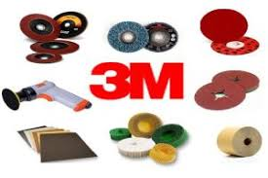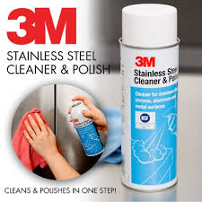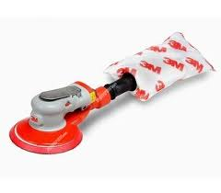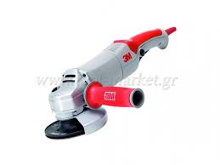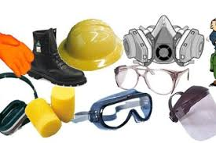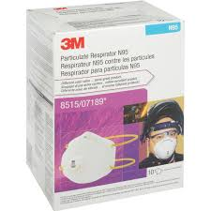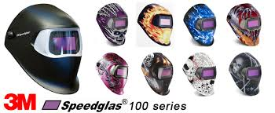

1. KNIPEX GERMANY

ALL KINDS TOOLS

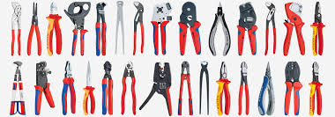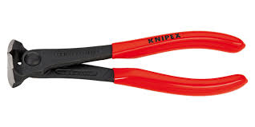

1. WEICON PROTECT

SPRAY FOR CLIEN, REPAIR STICK, SILICON , ADESHIVE SPRAY

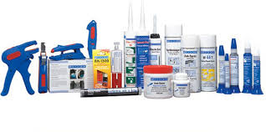 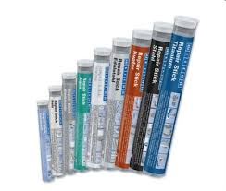

1. NITTO KOHKI

JET CHISEEL ( JT-20, JC-16, JEX-24, JEX-28, EJC-32A )

AIR CHIPPER ( ACH-16, CH-24 )

BORING AND PUNCHING

BEVELER MACHINE

PNUMATIEC GRINDER ( MLG-25, MLG-40, MAG-40, MAG-70 ) AND SANDER PNEUMATIC BELT SANDERS

CUPLA ( QUICK CONNECT COUPLINGS BRASS, STAINLESS STEEL, STEEL )

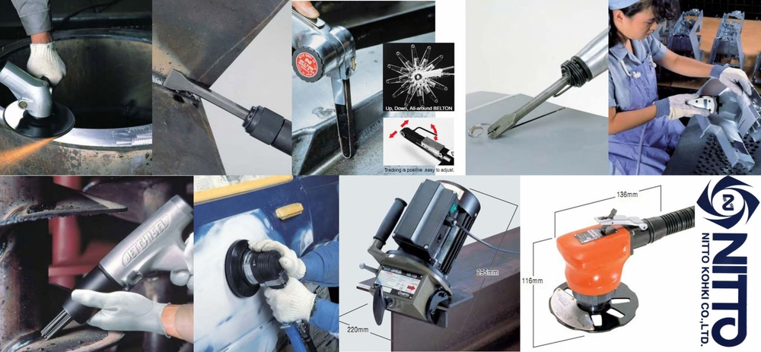

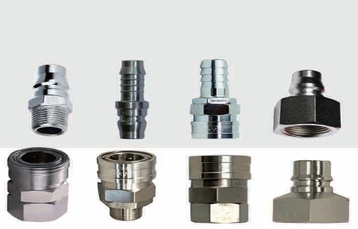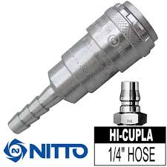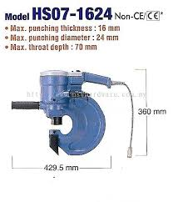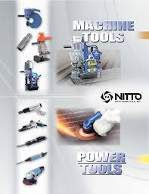

1. GRACO DIAPHRAGM PUMPS

HUSKEY PUMP ( PLASTIC, PTFE, TEFLOEN METAL , ALUM )

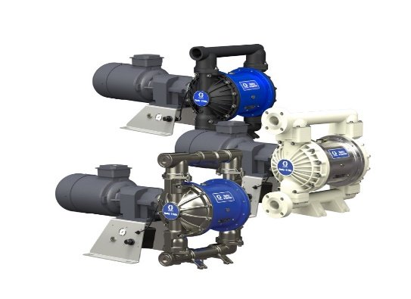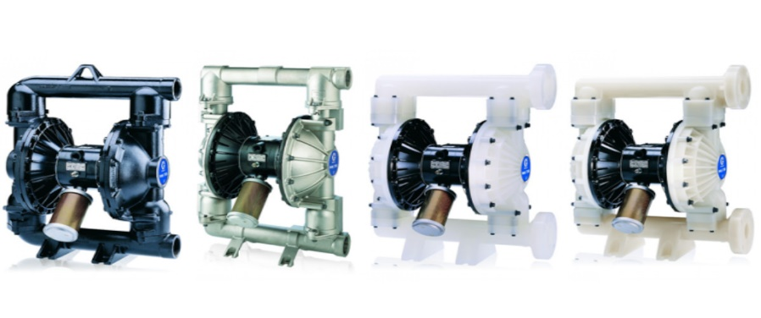

1. ORBITAL WELDING

PIPE CUTTING AND WELDING

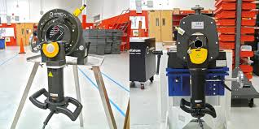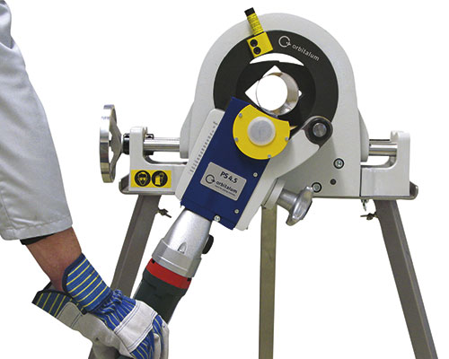

1. METABO POWER TOOLS

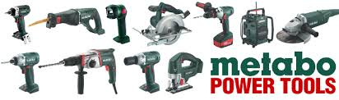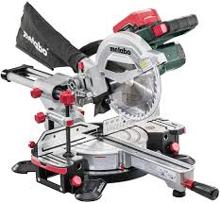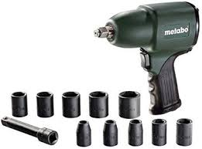

1. DELTAPLUS

SAFETY ITEM ( HARNESS, GLOVES, SHOES, COVERROLL, JACKET, WEBBING BELT, CARGO BELT, HELMET, MASK, GLASS )

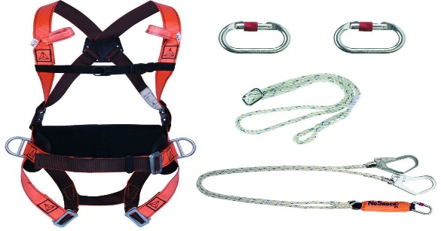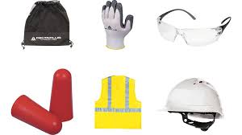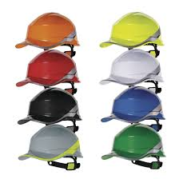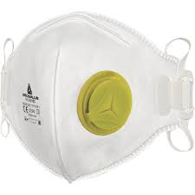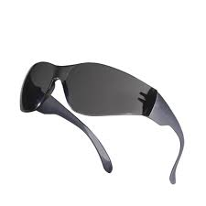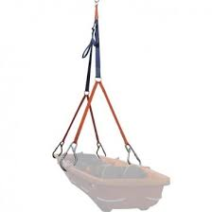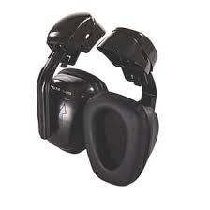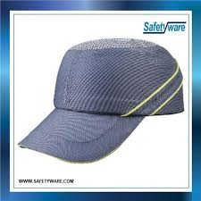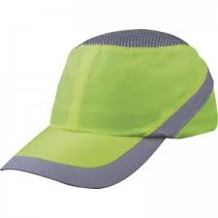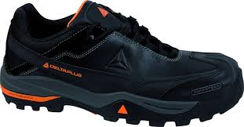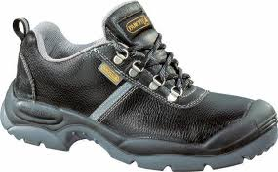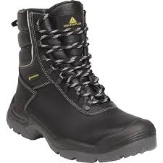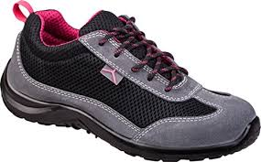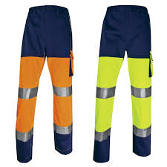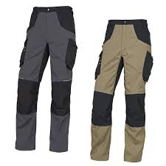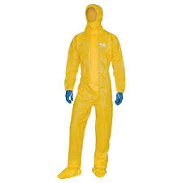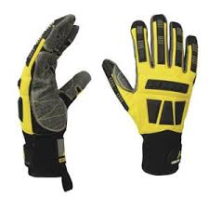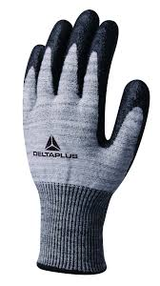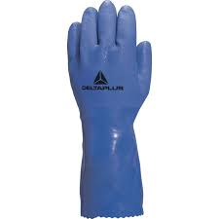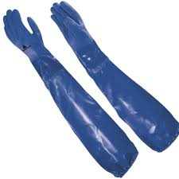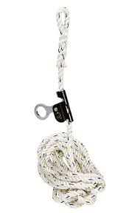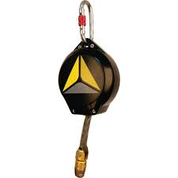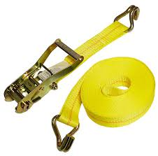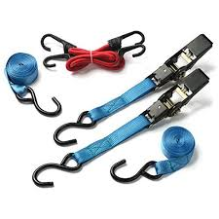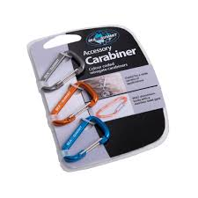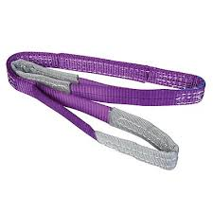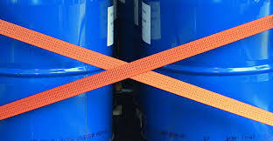

1. BATES CARGO PAK

DUNNAGE BAGS / CARGO PROTECTOR / ECO PROTECTOR

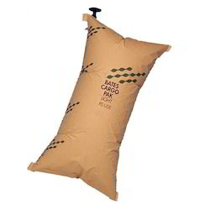 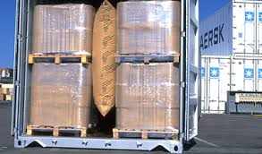 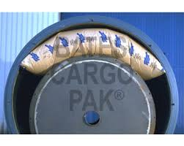 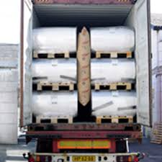

1. Martor Knife Tools

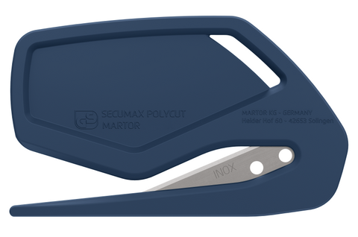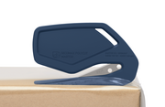Safety knife 
SECUMAX 320Safety knife 
SECUMAX 145Safety knife 
SECUMAX EASYSAFESafety knife 
SECUNORM 300Safety knife 
SECUNORM 500Safety knife 
SECUPRO MARTEGO 
GRAPHIC BLADES SET NO. 26SNAP-OFF-BLADE NO. 76